LAB 7

Laboratory Report for CS 2420

Brent Johnson

Computer Science

Texas State University

Department of Computer Science

Bj1107@txstate.edu

*Abstract* –  This lab served as a crash-course in latches and flip-flops. Latches and flip-flops are important because they serve as the building blocks for all digital memory. Without memory, our digital devices would be practically useless, databases could not exist, and the modern computer would be impossible to implement.

# Introduction

The theme of this lab is memory. Memory is important because without long-term storage (or short term storage for that matter), modern hardware and software would not be possible. Variables in program memory could not exist. Arguments in program functions could not exist. Programs themselves could not exist because there would be no physical place to store the code for later execution.

In order to gain an understanding of memory, today’s lab involved the creation truth tables for sequential logic, diagrams with flip-flops, and diagrams using switches implemented with only nand gates.

# Experimental Method

I began the lab by constructing the following diagram in DSCH.

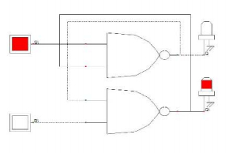

I then tested the results against expected results by populating a truth table with the results obtained by experimentation.

Next I created a SR latch with an enable button that activates or deactivates the input. I then used that schematic to test my predicted results against the obtained results from the experiment. Here is a copy of the diagram that I implemented.

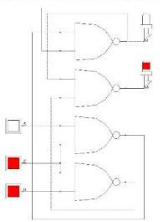

Next I created a D-latch with a pull-up resistor. I did the same procedure of comparing expected results against obtained results with the help of a truth table. Here is a diagram of the schematic I implemented.

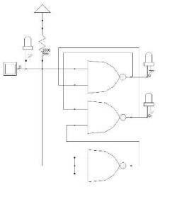

Finally, I created a circuit with flip flops. I created a schematic of the following diagram:

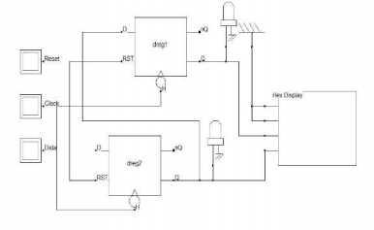

By attaching a hex display to two positive-edge triggered D flip-flops, I was able to implement a counter.

# Results

This is where you present and talk about your results.  Almost all results should go in a table, such as the ones you fill out in lab.  Any calculations you made should also be included.  Pictures of your calculations and/or tables, so long as they are readable, are fine if you are having formatting issues.  You also need to explain your results, such as where they what you expected, do they seem correct, do they closely match expected values, etc.

# Conclusion

If you had any difficulty in the lab and your results seem off, this is where you say why things seemed off and mention if you could have done anything to prevent it.  Explain what you learned in lab.